THEORY QUESTIONS

PART I

MAP SKILLS AND THE ENVIRONMENT
1.
Use the map of Dano District to answer Question 1
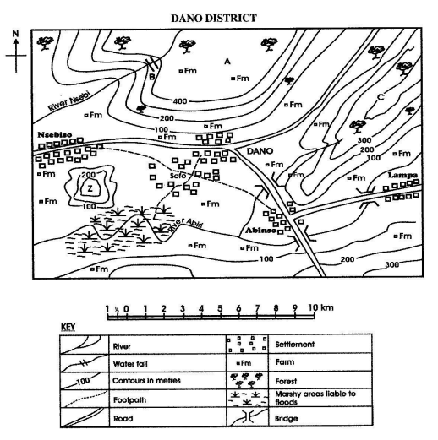
a)

State the:
i)

Direction of Nsebiso from Dano
ii)

Contour interval in metres
iii)

Distance by road from Abinso to Lampa in kilometres
iv)

Direction of flow of River Abiri
b)

Name the features marked A, B, C and Z on the map
c)

i)

What type of settlement is at Nsebiso
ii)

What is the main occupation of the people of Dano District?

2.
a)

State five characteristics of the harmattan
b)

In which two ways is the harmattan useful?
c)

Mention three disadvantages of the harmattan

PART II

NATIONAL COMMUNITY
3.
a)

Mention four achievements of Dr. Kwame Nkrumah.
b)

What are the four reasons that led to the overthrow of Dr. Kwame Nkrumah?

4.
a)

Name the four main vegetation types in Ghana.
b)

State four ways by which the vegetation is being destroyed.
c)

Mention two ways by which the vegetation can be protected.

PART III

WEST AFRICA, AFRICA AND THE WORLD
5.
a)

State four good effects that the coming of the Europeans had on West Africa.
b)

What four bad effects did the coming of the Europeans have on West Africa?

6.
a)

What is World Health Organization (WHO)
b)

Mention four achievements of WHO

